Greater Des Moines Softball Hall of Fame

Meeting September 10, 2013

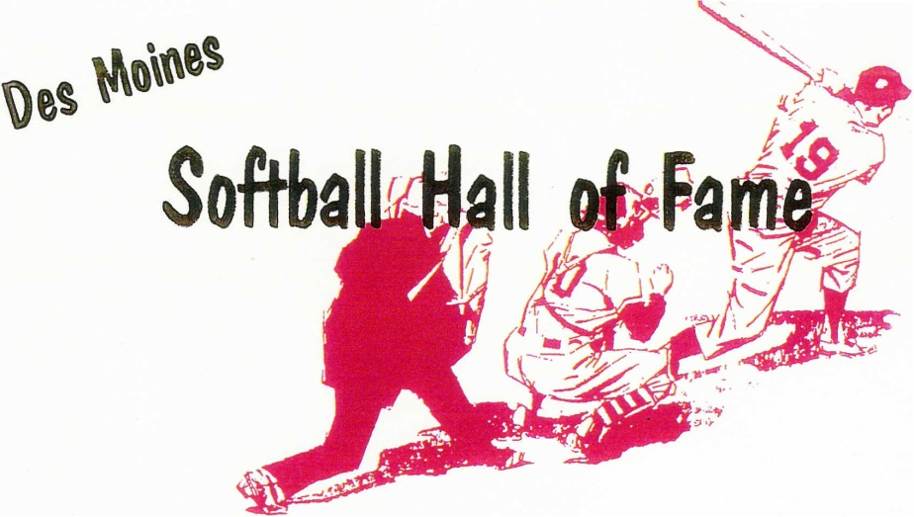
Pres. Mike Clark
VP. Chuck Welker
Sec. Tony Nelson
Treas. Kevin Walker

dmfastpitch@hotmail.com

Meeting held on September 10, 2013 Call to order: 7:02 PM

Meeting attended by 24 members:
Roger Aceto, Gary Alberhasky, Sammy Allgeier, Tyrone Anderson, Don Bailey, Gordy Baker, Wendell Blankenburg,
George Davis, Mike Clark, Mike Fuller, Floyd Hazelbaker, John Kelly, Dick Kimm, Denny Linderbaum,
Tony Nelson, Gene Olson, Randy Ripperger, Tony Russo, Dave Temple, Dave Thomason, Al Van Dyke, Kevin Walker,
Chuck Welker, Lou Yacinich Jr.

Minutes for May 14, 2013 meeting were approved as read - unanimous

Kevin Walker gave treasurer's report.
- Flowers were sent for the passing of Dale Schreurs and Oscar Calkins
- Paid Hilltop $303.74 for the May 2013 meeting for beer/pizza.
- All bills are paid: the current balance is $ 1296.43
- Treasurer’s report approved as read- unanimous

Old Business : None

New Business:

It was brought up that our HOF membership try to do a better job getting word out to members if another member or a member’s family has heath issues or a death of a member/family member. Privacy will be honored upon request of that member.

NAFA Tournament held recently. Overview was given by George Davis. The DSM area will be trying to keep the tournament in DSM for future NAFA events.

Discussions continued about eligibility of players. Do we need better definitions of who can be eligible, and what criteria should be used? Minimum time limits were mentioned along with a player having ties to the DSM metro area for a player to be eligible. Nothing was resolved and no motion was brought to the floor to change/add anything to the by-laws.

It was discussed and decided a motion can be made to add a player to the ballot if the membership requests that player to be added since there was nothing in the bylaws that prevented such a motion.

** Motion from Dave Temple to add Joe Mireles to ballot, second by Dave Thomason. Motion carried.

Read submitted resumes for the following:
Chris Bigelow
Tim Delger
Robert Mahaffe y
Bob McClish
Larry Silverstein
Ronnie Weidman
Lou Yacinich Sr.
Joe Mireles - by way of motion to add to ballot.

The balloting for this years HOF will be limited to picking SIX candidates of the eight that are eligible. The votes for each of the candidates were tabulated with the results below: Special Note: Two ballots were thrown out due to the ballot had more than SIX candidates marked. The majority needed to be elected was 12 votes. Those candidates in bold and marked with a * were elected to this years class.

Chris Bigelow – 6 votes
Tim Delger – 17 votes*
Robert Mahaffey – 21 votes*
Robert McClish – 20 votes*
Larry Silverstein – 17 votes*
Ronnie Weidman – 14 votes*
Lou Yacinich Sr – 18 votes*
Joe Mireles – 11 votes

The annual dinner was originally scheduled for Oct 27th 2013. A Motion to move to the dinner to Oct 20 was made by Roger Aceto, 2nd by George Davis. The motion was Approved. The new date for the Induction Dinner will be October 20, 2013 at 1pm.

Dinner was discussed to change from the traditional steak dinner to something more affordable. A couple options were presented to the membership – steak or pasta dinner.

A Motion to continue with the meal as a Ribye Dinner was made by Al Van Dyke. Gordy Baker second. Motion was Defeated by a vote of 7 in favor and 10 against.

Denny Linderbaum made a motion to allow the executive committee to decide on the dinner plans. Second by George Davis. Motion carried. The executive committee will work with Hilltop to come up with a dinner that is affordable.

A vote on the Officers was made – a motion to keep the Officers the same was made. Motion carried. No changes to the current Officers.

Fellowship continued while enjoying pizza, onion rings and beverages.

Meeting was adjourned at 8:40 PM

